Predicting Sleep Disorder Using Classification Methods

Mirza Md Ashif Iqbal  Dept. of Computer Science and Engineering  East West University  Dhaka, Bangladesh  2023-1-60-121@std.ewubd.edu | Fahim Ahamed Sifat  Dept. of Computer Science and Engineering  East West University  Dhaka, Bangladesh  2022-3-60-221@std.ewubd.edu

Md. Nahidul Islam

Dept. of Computer Science and Engineering

East West University
Dhaka, Bangladesh
2022-3-60-072@std.ewubd.edu
Abstract—Sleep is a must need for all. It’s important in all aspects of well-being, yet it may not getting the attention that it deserves. Disordered sleep is associated with serious disease. Accurate classification of sleep disorders is essential for proper diagnosis. The goal of this study aims to classify sleep disorders using the Random Forest, SVM, Logistic Regression and Decision Tree methods. The proposed algorithms achieved the accuracy of 96%, 94%, 64% and 93.33% respectively. The model reached a high accuracy of 96% using the Random Forest Model. Our study recognises the imbalancement of the datasets, but it also introduces us to the field of Machine Learning Algorithms.
Index Terms—Machine learning algorithms, deep learning architecture, classification, sleep disorder, Random Forest, SVM, Logistic Regression, Decision Tree.

I. INTRODUCTION
Sleep is vital for every human, but poor quality of sleep increases the risk to attract disease and illness, and vice versa [1]. Many findings show that Inaccurate decision making happens when a person’s sleep schedule is poor. Across the lifespan, our sleep duration and quality changes in a complex and many ways [2].

In this era of fast food chain, obesity is seen well over everywhere. Sleep apnea is associated with increased body mass [1].With increasing age, people will change their sleep routine, which will affect them with the decrease in sleep quality and quantity [2]. Most probably, this decreased sleep quality and quantity may not be the result of aging, but rather may result from other obstacles that comes with aging, such as medical conditions, poor physical health, increased medication use etc [2]. Many studies showed that sleep health across different ages are continuum, while observing lifestyle factors that may be related to sleep health [2]. There are some exceptions who are genetic predispositions which allows them to be free from the recommended sleep parameters and yet those people have normal and healthy lifestyle as well [1]. Approximately 5% to 10% of adults are "long sleepers," meaning they sleep for more than nine hours, and roughly 5% are "short sleepers," meaning they sleep for fewer than six hours [1]. The National Sleep Foundation Scientific Advisory Council has recommended sleep ranges for all age groups (see Table. 1) [1].

Age Group Sleep Duration
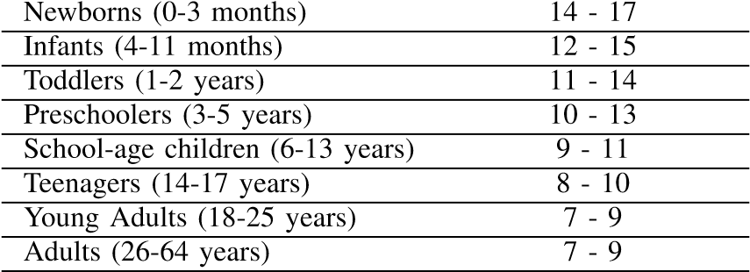
Older Adults (>=65 years) 7 - 8
Table 1: Recommended sleep duration by age group
5 stages of sleep: wakefulness, N1, N2, N3, and rapid-eye movement (REM) [4]. The stage where brain is still aware of the surroundings, is the Wakefulness stage [4]. N1 is the lightest stage of sleep cycle where brain waves are slow, and the muscles relax [4]. In addition, N2 is a little deeper stage of sleep cycle than N1, and the deepest stage of sleep cycle is the N3 stage. During this sleep stage, it is very hard to awake a person from the sleep [4]. In REM sleep stage, the brain waves show similarity with the sleep stage called wakefulness. Additionally, the eyes move rapidly back and forth during REM sleep stage [4]. The whole cycle takes ninety minutes to finish. The body and brain remain active throughout each stage of sleep, which is crucial [4]. Table 1's data demonstrates that while sleep duration and REM sleep diminish with age, sleep latency rises [2].

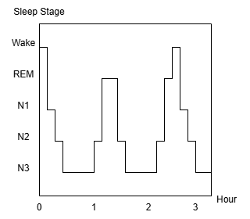

Fig. 1. Five Sleep Stages

After discussing about all of these, it is important to note that diseases linked to sleep disorders are caused by an increase in sleep latency and a decrease in sleep duration [2]. Modern lifestyles and people’s neglect of basic needs, are the main causes of the increase in sleep disorders which become even more irrelevant. The situation of COVID pandemic also put a negative impact to most people’s lifestyle in such sleep apnea and insomnia sleep disorders start to pop out more and more [4]. The most common sleep condition in adults is insomnia, which is defined by difficulty falling asleep or waking up too early. It can be caused by various factors such as stress, anxiety and physical conditions [2]. Sleep apnea is potentially a serious sleep disorder in which the symptoms is breathing repeatedly stops and its starts during sleep. During the sleep, each pause in breathing can last for a few seconds to a few minutes and often that can occurs so many times.

The main purpose of this research is to develop a classification model which can go through the features in the dataset then predict sleep disorders based on those information [3]. For relatively small datasets, traditional Machine Learning Algorithms (MLAs) can be employed, which is faster and relatively simple [4].

II. LITERATURE REVIEW
In recent years, sleep disorder detection and sleep-stage classification have been explored due to MLAs’ easy train and test to making most of them automated. These approaches are taken to replace the manual interpretation of polysomnography (PSG) with data-driven techniques using Deep Leaning Algorithms (DLAs) for more faster and consistent results.

Idfian Azhar Hidayat in [3] reviewed several studies using Random Forest with MLAs for sleep classification. The article reviewed 10 papers using diverse MLAs, comprising Adaptive Synthetic Support Vector Machine (ADASYN-SVM) and Synthetic Minority Oversampling Technique-Support Vector Machine (SMOTE-SVM) Methods, Fuzzy Neural Network (FNN), Random Forest and Logistic Regression (LR). The model may significantly improve the accuracy for classification sleep stage utilizing improved Gini-Index Random Forest-Based MLAs. However, The study relies on a single dataset, which may limit the observation. Not only that, but also the dataset is imbalanced. Thus, the model is only validated on a test subset from the same dataset, not on external dataset.

Alshammari et al. [4] provided a comprehensive review of applying machine learning algorithms (MLAs) to sleep disorder classification. The article reviewed 33 papers using diverse MLAs. The knearest neighbours (KNN), SVM, Decision Tree (DT), Random Forest and Artificial Neural Network (ANN) deep learning algorithms were assessed. The ANN achieved the highest classification accuracy of 92.92%. Nonetheless, the dataset includes 400 rows and 13 features, which may limit the findings to broader or more diverse datasets.

SwSleepNet, a deep learning sleep stages classifier proposed by Zhu et al. [5], used Sequential CNN for extracting the most significant features. They applied this method to three datasets: clinical data of Huashan Hospital Fudan University (HSFU), Sleep-EDF Expanded, and Montreal Archive of Sleep Studies, and achieved an accuracy of 81.8%, 84.5%, and 86.7%, respectively.

Another article [6] reviewed 55 papers and discussed the significance of REM and Non-REM Sleep Cycles. In addition MLAs, such as Ensemble Bagged Trees (EBT), Ensemble Boosted Trees (EBooT), SVM, KNN, are used for detecting sleep disorder from electroencephalogram (EEG) and electrocardiogram (ECG) signals. The author has managed to achieve the best accuracy of 91.3%. However, the author suggested that Deep Learning (DL) techniques such as CNN, LSTM could be explored in the future, especially with larger and more diverse datasets.

Researchers in [7] integrated EMG (Electromyography) and ECG characteristics using DLAs (Deep Learning Architectures). The suggested deep learning framework yielded a weighted F1 score of 0.57 and a mean accuracy of 72%. Using a variety of DLAs, including a proprietary Deep Neural Network (DNN), the researchers examined forty publications. However, researchers hope to increase the amount of biosignals used in recognition in further studies. Photoplethysmography (PPG) data acquired in extremely inconspicuous ways can be analysed using signal processing algorithms designed for ECG analysis.

Sheikh Shanawaz Mostafa and associates reviewed several studies that employed CNN, DL, and Recurrent Neural Networks (RNN) with MLAs to identify sleep apnoea in [8]. 21 of the 255 papers that the article claimed to analyse were selected based on inclusion and exclusion criteria using the recommended reporting items for systematic reviews and meta-analyses (PRISMA) approach.

The paper [9] states that a high number of irrelevant or less relevant characteristics can reduce machine learning's runtime performance and classification accuracy. Researchers often employ feature selection techniques to narrow down the number of irrelevant features to a smaller number of more relevant ones. However, these methods might not be sufficient to enhance performance on their own. This study proposes a novel hybrid feature projection model to improve classification performance in the diagnosis of sleep disorders. We have used the MCMST Clustering algorithm with others feature projection methods like PCA, LDA, SVD, t-SNE, NCA, Isomap, and PR, during the data preprocessing stage. The proposed model achieved a classification accuracy of 96.27% using Kernel PCA, demonstrating its superiority over pure KNN and KNN with other feature projection methods.

Several machine learning models like as SVM, Random Forest, KNN, Logistic Regression, Catboost, and Light Gradient Boosting Machine (LGBM), were researched by Ramesh et al. [10]. Using the data from the Wisconsin Sleep Cohort dataset, they optimised the models' hyperparameters for recognize people with or without interrupted sleep apnoea (OSA) using Bayesian optimisation and genetic algorithms. SVM had the highest accuracy that is (68.06%), and the sensitivity is (88.76%), and specificity is (40.74%), and F1-score shows (75.96%) of all the classifiers examined.

To identify sleep apnoea from a single-lead ECG, the authors in [11] employed MLAs, CNNs, LSTM, bidirectional LSTM, and gated recurrent units. The suggested algorithms, which have a total of 70 records, were validated using the apnoea-ECG dataset. The classification accuracy of their suggested hybrid models was 80.67%, 75.04%, 84.13%, and 74.72%. The CNN beat the other algorithms in the race of accuracy, and the hybrid CNN and LSTM network founded as the most efficient one. Also they tested the effectiveness of some deep learning algorithms and find out that, in contradict to traditional MLAs, deep learning algorithms are able to develop automatic sleep apnoea diagnosis.

This study [12] used transfer learning with the AlexNet framework, trained on ECG data from the MIT-BIH polysomnographic database, to predict obstructive sleep apnoea (OSA). The accuracy, sensitivity, and precision of the Stochastic Gradient Descent with Momentum (SGDM) algorithm were 86.63%, 92.20%, and 90.55%, respectively. The study highlights how deep learning can improve non-invasive OSA diagnosis.

In another study, Tareq [13] explored how machine learning can identify sleep disorders such as sleep apnoea and insomnia. There was a needed for a modern automated systems that use medical data because the traditional methods of diagnosing these conditions were so much costly and time consuming. Using the information from the Sleep Health and Lifestyle Dataset, they applied a Random Forest Classifier to find out and predict the sleep issues and this method correctly identified 88% of sleep problems from the data.
Ref. | Year | Algorithm Used | Accuracy
[3] | 2023 | Random  Forest | 88%
[4] | 2024 | KNN, SVM,  DT,  RF,  ANN, | 84.96%  64.6%  86.73%  88.5%  91.15%
[5] | 2024 | CNN | 81.8% 84.5%  86.7%
[6] | 2021 | EBT, EBooT,  SVM, KNN | The best accuracy of 91.3%
[7] | 2020 | A custom DNN | A mean accuracy of 72%
[8] | 2019 | CNN, RNN, LSTM | 90.8%,  88.2%,  97.08%
[9] | 2024 | KNN | Classification accuracy of 96.27%
[10] | 2021 | SVM, RF,  KNN, LGBM | 68.06%, with a sensitivity of 88.76%, a specificity of 40.74%, and an F1-score of 75.96%
[11] | 2021 | MLAs, CNNs, LSTM,  bidirectional LSTM | 80.67%, 75.04%,  84.13%, 74.72%
[12] | 2023 | SGDM | 86.63%, with sensitivity at  92.20% and precision at  90.55%
[13] | 2024 | RF Classifier | 88%

Table-2: Related Word

III. PROPOSED METHODOLOGY
This study uses the Random Forest, SVM, Logistic Regression and Decision Tree methods to classify sleep disorders based on the Sleep Health and Lifestyle dataset and Sleep Disorder Diagnosis dataset. Those datasets contain detailed information on sleep habits. There are many factors that actively effects our sleep habit such as occupation, physical activity, stress levels, and many more. In this study, the datasets were processed and divided into training and testing subsets (X_train, X_test, y_train, y_test).

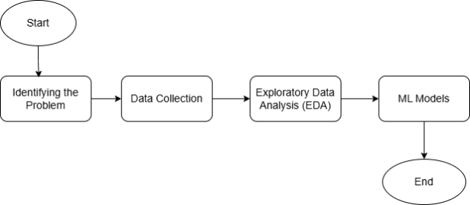

Fig. 2. Flow chart of the Methodology

A. Identifying the Problem
The problem of this study is to find out sleep disorders based on the given data from Sleep Health and Lifestyle and Sleep Disorder Diagnosis datasets. Sleep disorders refer to a variety of conditions such as Insomnia, Sleep Apnea etc. that can affect the quality, and duration of a person’s sleep. Sleep disorders can have many negative impacts on a person’s life, physical, and emotional health etc. This research has developed a meaningful method to diagnose and predict sleep disorders based on those problems.

B. Dataset Collection
In this study, the datasets which are “Sleep Health and Lifestyle” and “Sleep Disorder Diagnosis”, were collected from Kaggle to use supervised ML models of classification on them. The classification of sleep disorders using the Random Forest, SVM, Logistic Regression and Decision Tree models are carried out based on features related to sleep. Those datasets have information that include unique ID, gender, age, occupation, sleep duration (hours), sleep quality (scale 1-10), physical activity level (minutes/day), stress level (scale 1-10), BMI category, blood pressure (systolic/diastolic), heart rate (bpm), and daily steps.

C. Exploratory Data Analysis (EDA)
In the EDA section, we present visually compelling charts and graphs to highlight the key findings. Like displaying the first and last 5 rows of the dataset, checking for any missing (null) values in the dataset, handling that null value, showing correlation matrix, showing all kind of plots( i.e.: scatter plot, pie chart, histogram, boxplot, count plot) that might convey some information and write what we understood from the graphs.

- “Sleep Disorder Diagnosis” Dataset

- Relationship between sleep duration and sleep quality:

From the Fig. 4, we can see that the optimal Quality of Sleep can be achieved if the Sleep Duration is above 6.5 hours. But less than that period of sleep will put negative effect on sleep quality.

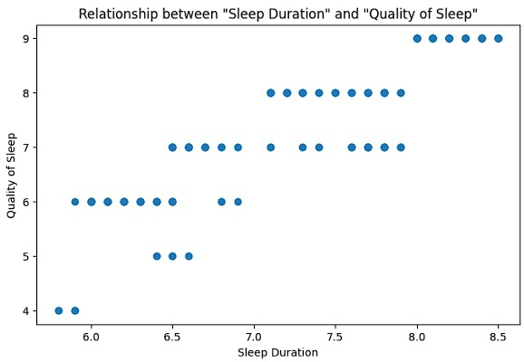
Fig. 3. Relationship between sleep duration and sleep quality

- Comparison of Occupation with Sleep Quality:

In Fig. 5, the person with Nurse, Accountant, Lawyer and Engineer Occupations are having the best quality of sleep. On the other hand, Scientists and Sales Representatives are suffering from worst quality of sleep.
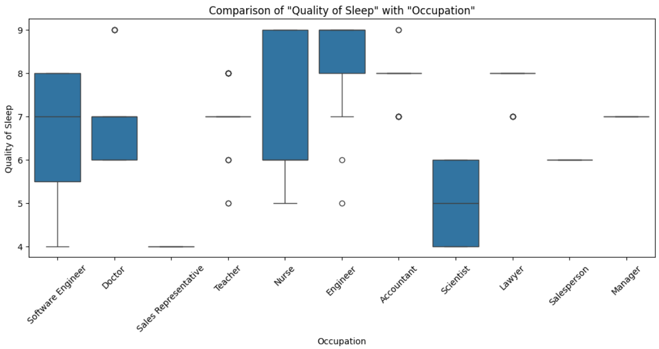

Fig. 4. Comparison of Occupation with Sleep Quality
- Comparison of Sleep Duration with Occupation:

As for the Sleep Duration, the optimal sleep is experienced by the Accountants, Engineers and Lawyers which are shown in Fig. 6. The Opposite can be seen for Sales Representatives and Scientists.
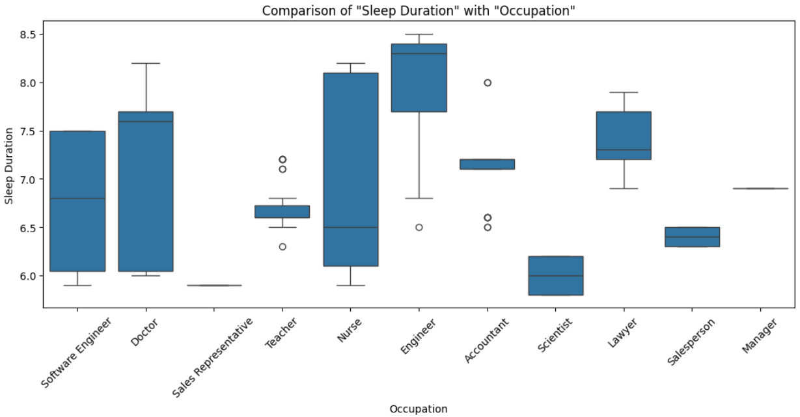
Fig. 5. Comparison of Sleep Duration with Occupation
- Sleep Disorder within Male and Female:

From the Fig. 7, we can distinguish the fact that Sleep Apnea mostly occurs for Female, and Insomnia occurs slightly more for Male. Most Male doesn’t have any sleep disorder.
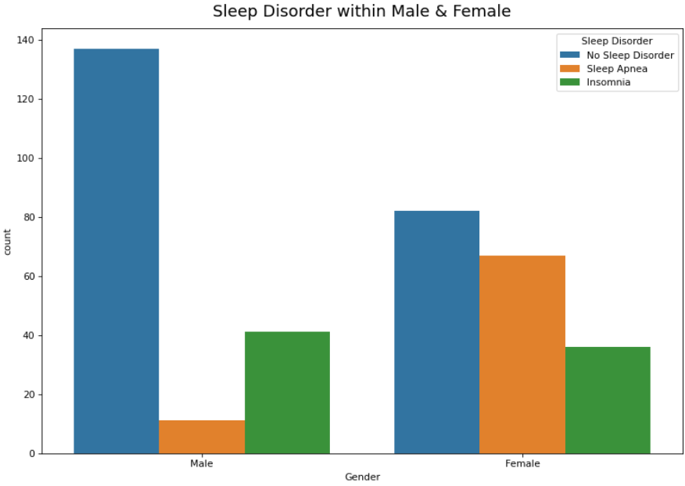
Fig. 6. Sleep Disorder within Male and Female

- “Sleep Health and Lifestyle” Dataset

- Relationship between sleep duration and sleep quality:

The relation between Sleep Duration and Sleep Quality in this dataset is quite versatile. As we can see in Fig. 8, a person with 4 hours of sleep having almost 10 out of 10 sleep quality. On the other hand, a person nearly having 10:30 hours of sleep, is reviewing their sleep quality less than 2. From here, we can tell, the most optimal Sleep duration to achieve the moderate Quality of Sleep is between 5 and 7 hours of sleep

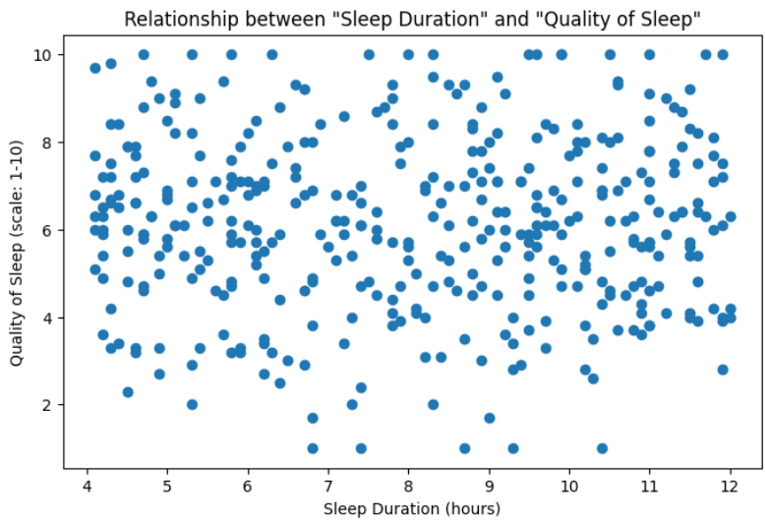
Fig. 7. Relationship between sleep duration and sleep quality

- Sleep Disorder within Male and Female:

In Fig. 9, Sleep Apnea occurs for Female, and Insomnia occurs slightly more for Male just like the previous observation. But for this dataset, between Male and Female, slightly more Female doesn’t have any sleep disorder.

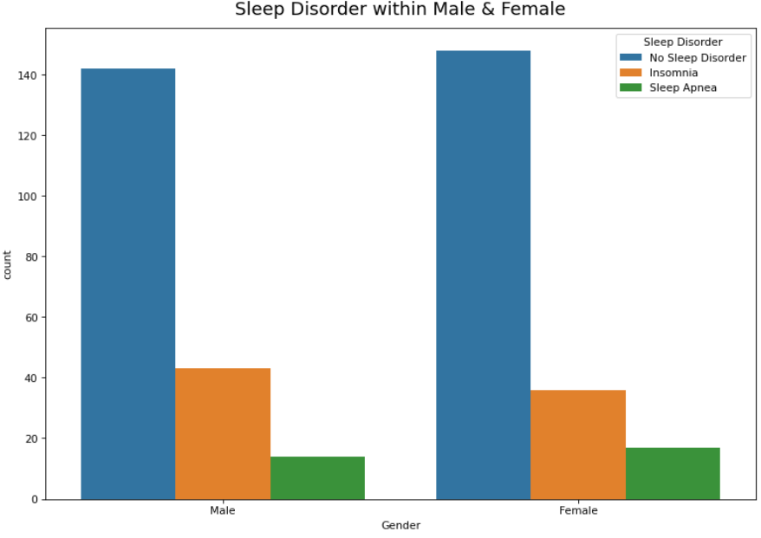
Fig. 8. Sleep Disorder within Male and Female

D. ML Models
We have followed a pipeline with ColumnTransformer to assemble the ML process more structured way.

As our datasets contains integer, float and string (object) values, we had to encode the ‘object’ features using OneHotEncoder, which is a technique used to convert categorical (text) data into numeric form so that ML models can understand it. This happens under preprocessing.

After that, we used a method called SMOTE (Synthetic Minority Over-sampling Technique), used to handle imbalanced datasets. This method creates new synthetic samples without duplicating existing ones.

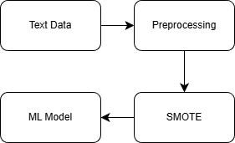
Fig. 9. ML Pipeline

Random Forest Model
Random Forest (RF) combines individual observation of collective set of data. It’s the extension of Decision Tree.

First, to set up the environment, we imported the random forest from sklearn library. After that separate features and target value. Both “Sleep Disorder Diagnosis” and “Sleep Health and Lifestyle” datasets are imbalance dataframes. So, by creating the pipeline with ColumnTransformer, we manage to handle that problem.

For the Random Forest Classifier, “n_estimators” to 40 and the “random_state” to 99. By setting up the “random_state” to 99, we have formed a seed which will help us to get the same result.

Now, the random forest model manages to get the accuracy of 96.0% on the “Sleep Disorder Diagnosis” dataset. By using “Sleep Health and Lifestyle” dataset the next time the accuracy we get was 77.5%.

2) SVM Model
Support vector machine, in short SVM, is a supervised MLA, which is used in classification by setting up the “kernel”.

In SVM, we use hyperplane which is a decision boundary that separates data point of different classes in the feature space.

$$y=mx+c$$
Here, ‘m’ means weight and ‘x’ means features. ‘c’ is noted as biased intercept.

There are 3 types of Kernel, Linear, Polynomial and Radial Basis Function (rbf). As we’re classifying the datasets, so we’ve set “kernel” to ‘linear’, and set the “random_state” to 99. SVM regularization parameter (C) assigned to 1 and “gamma” to 0.

SVM model went through the same pipeline as the Random Forest model. After that, SVM scored 92.0% accuracy on “Sleep Disorder Diagnosis” dataset.

Logistic Regression Model
Logistic Regression (LR) is a ML model, which is great at conducting binary prediction such as 0 or 1, spam or not spam. In the "random_state", we can put any number here to sets a fixed seed.

$$y= \frac{1}{1+e^{-(a_{0}+a_{1}x)}}$$

To find out the probability event, we use Sigmoid Function, where y is the predicting variable, $a_{0}$ is the intercept point and $a_{1}$ is the coefficient which indicates the changes in y axis after changing the x value.

Logistic Regression model achieved an accuracy of 64.0% on the “Sleep Disorder Diagnosis” dataset, while the accuracy for the “Sleep Health and Lifestyle” dataset was reported 47.5%.

Decision Tree Model
Decision Tree (DT) is mostly used for classification problems. This model creates a tree from root to classify the dataset, use features to predict the perfect decision. If the dataset is impure, then the information gain will be less than the dataset with pure dataset.

Decision Tree model manage to get the second highest accuracy on “Sleep Disorder Diagnosis” dataset which is 93.33%, while the accuracy for the “Sleep Health and Lifestyle” dataset was reported 75%.

IV. EXPERIMENTAL SETUP
The Experimental datas that were collected from Kaggle and conducted many experiments to demonstrate the effects of our proposed methodology in the previous section. We experimented on Google Colab in a pc which has 6 cores 12 threads with 3.9 GHz CPU, 32GB Ram with 3200MHz. The dataset “Sleep Health and Lifestyle” has 400 rows and 13 columns, and “Sleep Disorder Diagnosis” dataset consist of 374 rows and 13 columns as well.

V. RESULTS AND DISCUSSIONS
In our Experiments, we have used 4 ML models, where we used 2 different datasets “Sleep Disorder Diagnosis” and “Seep Health Lifestyle”. Our Random Forest model is build using 40 trees. We cross validated 10 times to resample.

All of the models were trained and evaluated using training subset and testing subset respectively [3]. Here, Random Forest Model performed better than the other 3 models (SVM, LR, DT) on both “Sleep Disorder Diagnosis” and “Seep Health Lifestyle” datasets, by achieving a good accuracy level, 96% and 77.5% respectively.

Performance Metrics
To assess the performance of the classification, we can use Confusion Matrix, where the parameters are True Positive (TP), True Negative (TN), False Positive (FP), and False Negative (FN) [8]. When the prediction outcome is true and it is also true in reality, it will indicate TP. The opposite condition will indicate TN [8]. If the prediction outcome is true but it is false in actual outcome, then it will be denoted as FP. And the opposite condition will indicate FN [8].
We can define the precision, recall, f1-score and accuracy as [8]:

$$Precision=\frac{TP}{TP+FP}$$

$$Recall=\frac{TP}{TP+FN}$$

$$F1-Score=2\frac{Precision * Recall}{Precision+Recall}$$

$$Accuracy=\frac{TP+TN}{TP+TN+FP+FN}$$

Dataset Name | ML Model | Precision | Recall | f1 – Score | Accuracy
Sleep Disorder Diagnosis | RF | 0.96 | 0.96 | 0.96 | 0.96
 | SVM | 0.93 | 0.92 | 0.92 | 0.92
 | LR | 0.76 | 0.64 | 0.65 | 0.64
 | DT | 0.93 | 0.93 | 0.93 | 0.93
Sleep Health and Lifestyle | RF | 0.70 | 0.78 | 0.73 | 0.78
 | LR | 0.68 | 0.47 | 0.56 | 0.47
 | DT | 0.78 | 0.75 | 0.77 | 0.75

Table-3: Summary of all ML model used on the datasets

Comparison with Existing Models

Hidayat et al. [3] have also performed a multiclass classification (NAN, Sleep Apnea, Insomnia), without handling the missing values. But in our model, we handled the missing values and made it more readable.

Alshammari et al. [4] used ANN model which achieved a good level of accuracy. Our model manage to overtake the performance levels with very slight difference.

The researcher in [10], used cross-validation strategy to resample the dataset and in their model, SVM achieved the highest performance measurements, where the accuracy, precision, F1-score and recall values are 68.08%, 66.36%, 75.96% and, 88.76% respectively.

To calculate overall performance measurement, we used,

$$Overall=\frac{Accuracy+Precision+F1-score+Recall}{4}$$

Models | Accuracy | Precision | f1-Score | Recall | Overall
RF [3] | 0.88 | 0.88 | 0.88 | 0.88 | 0.88
ANN [4] | 0.93 | 0.92 | 0.92 | 0.94 | 0.93
SVM [10] | 0.68 | 0.66 | 0.76 | 0.89 | 0.68
Proposed | 0.96 | 0.96 | 0.96 | 0.96 | 0.96

Table-4: Comparison with existing models

VI. CONCLUSION
We found interesting connections between sleep length, physical activity, stress levels, and sleep quality in our thorough examination of sleep health and lifestyle. The results highlight the significance of maintaining sufficient sleep duration, controlling stress levels, and participating in regular physical activity for the best possible quality of sleep. Additionally, the machine learning model created for sleep disorder prediction demonstrated encouraging performance metrics and accuracy, opening the door for possible uses in sleep disorder screening. This study offers a reliable and effective machine learning-based approach that uses physiological and lifestyle data to predict sleep disorders. The system reached a high accuracy of 94.68% by using techniques like Random Forest and on a well-structured dataset, proving its capacity to correctly classify individuals.

The study recognises limitations because of the scale of the dataset, but it also emphasises the promise of MLAs in this field. Further research directions include integrating unsupervised learning methods and advanced feature extraction techniques to improve classification accuracy. The model’s generalisability and practical applicability will also be improved by growing the dataset and investigating cutting-edge methods. In a practical sense, the suggested methodology can be used to help identify and categorise sleep problems in real-world health diagnostics, such as wearable health monitoring devices or automated systems in sleep clinics. Particularly in environments with limited resources, these technologies can greatly lessen the need for manremote or resource-limited settings. Future improvements like real-time data integration, advancedstage classification, and mobile deployment can further enhance the model’s impact on public health and wellness.

REFERENCES
- Dedhia, P. and Maurer, R., 2022. Sleep and health-a lifestyle medicine approach. J. Fam. Pract, 71, pp.S30S34.
- Dzierzewski, J.M., Sabet, S.M., Ghose, S.M., Perez, E., Soto, P., Ravyts, S.G. and Dautovich, N.D., 2021. Lifestyle factors and sleep health across the lifespan. International Journal of Environmental Research and Public Health, 18(12), p.6626.
- Hidayat, I.A., 2023. Classification of sleep disorders using random forest on sleep health and lifestyle dataset. Journal of Dinda: Data Science, Information Technology, and Data Analytics, 3(2), pp.71-76.
- Alshammari, T.S., 2024. Applying machine learning algorithms for the classification of sleep disorders. IEEE Access, 12, pp.36110-36121.
- H. Zhu, Y. Wu, Y. Guo, C. Fu, F. Shu, H. Yu, W. Chen, and C. Chen, “Towards real-time sleep stage prediction and online calibration based on architecturally switchable deep learning models,” IEEE J. Biomed. Health Informat., vol. 28, no. 1, pp. 470–481, Jan. 2024.
- Sharma, M., Tiwari, J., Patel, V. and Acharya, U.R., 2021. Automated identification of sleep disorder types using triplet half-band filter and ensemble machine learning techniques with EEG signals.
- Jarchi, D., Andreu-Perez, J., Kiani, M., Vysata, O., Kuchynka, J., Prochazka, A. and Sanei, S., 2020. Recognition of patient groups with sleep related disorders using bio-signal processing and deep learning. Sensors, 20(9), p.2594.
- Mostafa, S.S., Mendonc¸a, F., G. Ravelo-Garc´ıa, A. and Morgado-Dias, F., 2019. A systematic review of detecting sleep apnea using deep learning. Sensors, 19(22), p.4934.
- A. S¸enol, T. Talan, and C. Akturk, “A new hybrid feature¨ reduction method by using MCMSTClustering algorithm with various feature projection methods: A case study on sleep disorder diagnosis,” Signal, Image Video Process., vol. 18, no. 5, pp. 4589–4603, Jul. 2024.
- J. Ramesh, N. Keeran, A. Sagahyroon, and F. Aloul,
“Towards validating the effectiveness of obstructive sleep apnea classification from electronic health records using machine learning,” Healthcare, vol. 9, no. 11, p. 1450, Oct. 2021.
- M. Bahrami and M. Forouzanfar, “Detection of sleep apnea from single-lead ECG: Comparison of deep learning algorithms,” in Proc. IEEE Int. Symp. Med. Meas. Appl. (MeMeA), Jun. 2021, pp. 1–5.
- Chun-Cheng Peng and Chu-Yun Kou. 2023. Sleep Disorder Classification Using Convolutional Neural Networks. IFIP International Journal on Artificial Intelligence Applications and Innovations (2023), 539–548.
- W. Z. T. Tareq, “Sleep disorders detection and classification using random forests algorithm,” in Decision Making in Healthcare Systems. Cham, Switzerland : Springer, 2024, pp. 257–266.

